A000-Afr-Tanzania-Dan-Mancala Board Game-Early 20th c

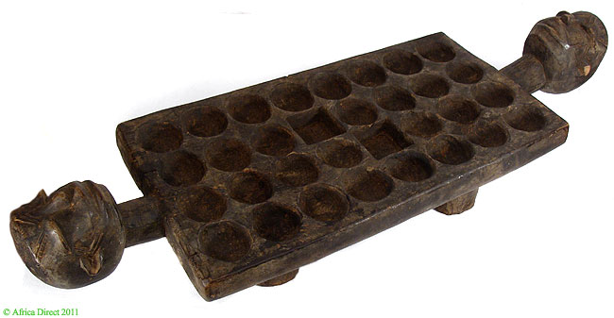

Fig. 1. Afr-Tanzania-Dan-Mancala Board Game-Early 20th c

Case No.: 6

**Accession No.**

**Formal Label:** Afr-Tanzania-Dan-Mancala Board Game-Early 20th c

**Display Description:**

Makonde style on this board game is recognized by the style of carved head at each end of the board.  The four-legged board is composed of 32 play pits. The surface shows much handling.

Such boards were used in the game commonly known as Mancala (mankala)  in several African cultures. This game has been played by African peoples over the centuries. It's a family game that involves several players. Adults (men) and children play it indistinctly. The playing pieces consist of stones, seeds, or shells that the players distribute one by one into the play pits. The game has its own rules and the players can make their own rules as well. The championship goes to the player who will have the most seeds in his home pit after a certain number of games in a match. This game is still popular today. Mathematics skill is the key to become a famous player of Mancala.

**LC Classification:**

**Date or Time Horizon:**

**Geographical Area:**

**Map:**

**GPS coordinates:**

**Cultural Affiliation: Dan**

**Media: wood**

**Dimensions:** 35.5 inches length x 9 inches width

**Weight:**

**Condition:** Small splits, scrapes and cracks are a normal part of their patina attesting to their age and extensive use.

**Provenance:** From a Tanzanian Collection

**Discussion:**

**References:**

De Voogt, Alexander J. 1997. *Mancala Board Games*. London: British Museum Press, 1997